Purpose
This project is a hands-on learning experience aimed at understanding the fundamentals of full-stack web development, gaining practical experience through building this application such as:
- Using Flask as a web framework.
- Integrating MySQL for data storage and user authentication.
- Designing front-end pages using HTML and CSS.

Overview
A To-Do List Web Application is a task management tool that enables users to efficiently create, track, and manage their daily activities. This application helps individuals stay organized and productive by maintaining a personalized list of tasks. Users can log in, add new tasks with status and completion dates, edit existing entries, and remove them as well. The application stores data in a backend database, MySQL.
Functional Requirements
1. User Authentication
- Sign Up: New users can register using a unique username and password.
- Log In: Registered users can log in to access their tasks.
- Log Out: Users can end their session.

2. Task Management
- Add Task: Users can add tasks with details such as task name, status (e.g., Not Started, In Progress), and an optional completion date.
- View Tasks: Displays a list of all tasks added by the logged-in user.
- Update Task: Users can modify an existing task’s content, status, and completion date.
- Delete Task: Tasks can be removed individually using a delete button next to each task.

3. Database Integration
- MySQL Storage: All task and user information is stored in a MySQL database using Flask-MySQLdb.
- User-Specific Data: Each user only sees their tasks, managed through session-based filtering.

4. Error Handling and Validation
- Empty Field Checks: The form prevents submission of tasks with blank fields.
- Duplicate Usernames: During sign-up, duplicate usernames are managed with an error message.
- Invalid Login Feedback: Incorrect credentials display an error message.

Functional Diagram
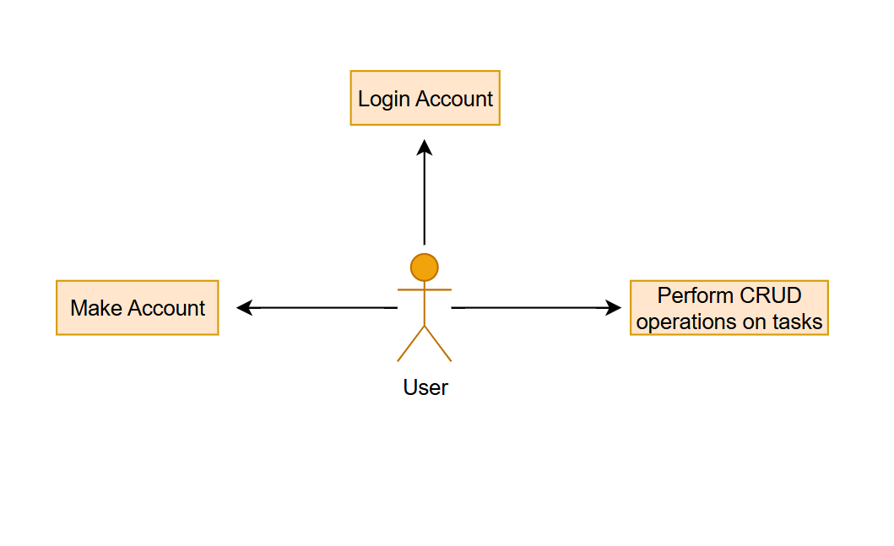

Database
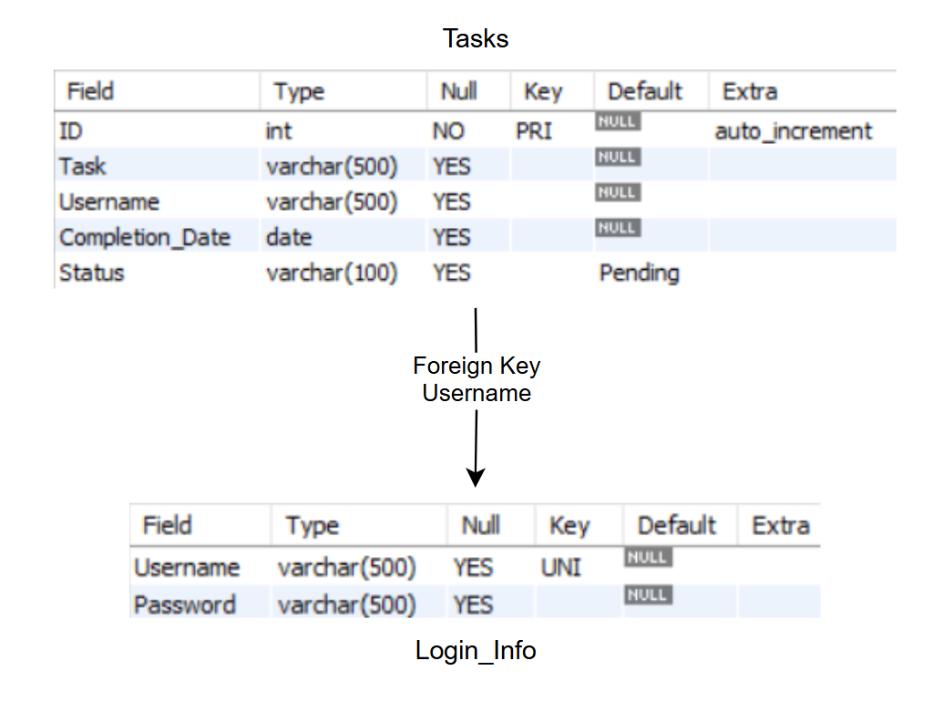

User Interface

User interface is the bridge between end-user and system. Following section list various visuals representing the application, containing buttons, text, and input controls.
Login
This is the default screen presented at the launch of the application. The user has the option to either login or sign up if they do not have an existing account.
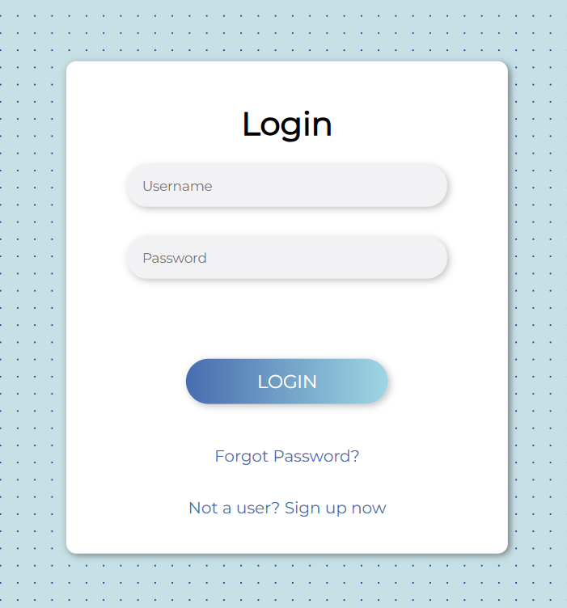

If username or password is entered wrong, access is denied, and an error message is shown. The user can click on Forgot Password link to change their password.
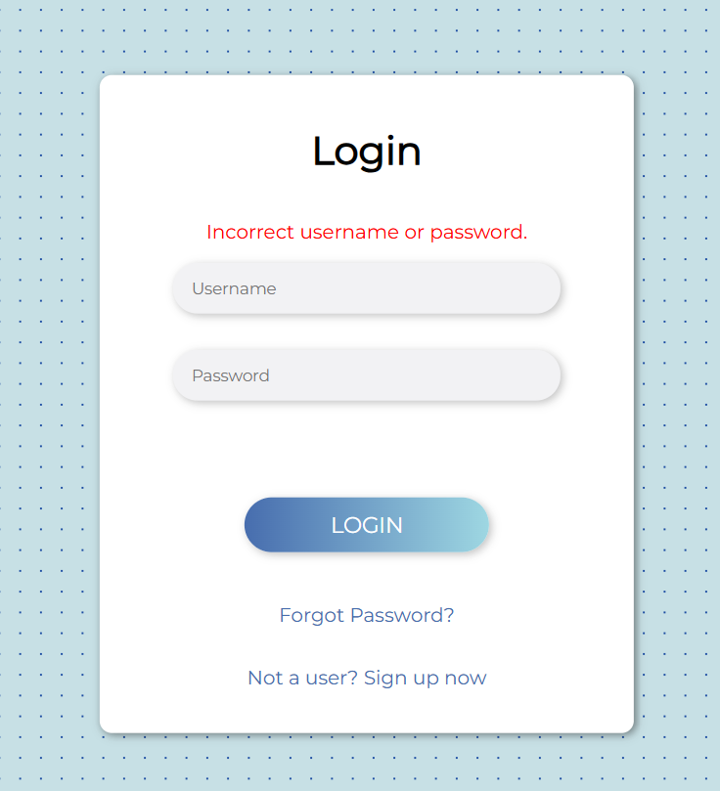
Forgot Password
Forgot Password screen is opened when user clicks Forgot Password text on Login screen. Here the user can change their password.
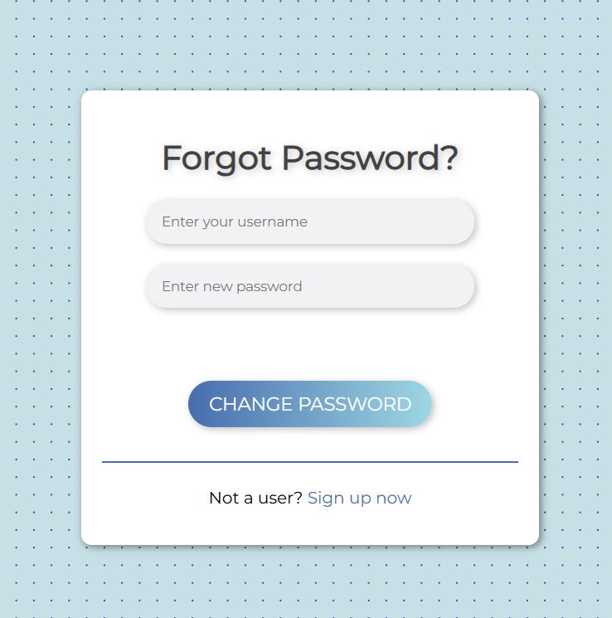
User enters their username and new password. The password is changed, and user can login in with the new password.
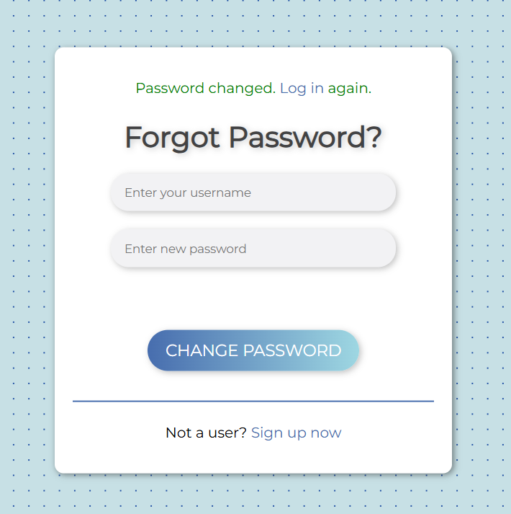
If there is no existing username, an error message is shown. The user can sign up and make a new account.
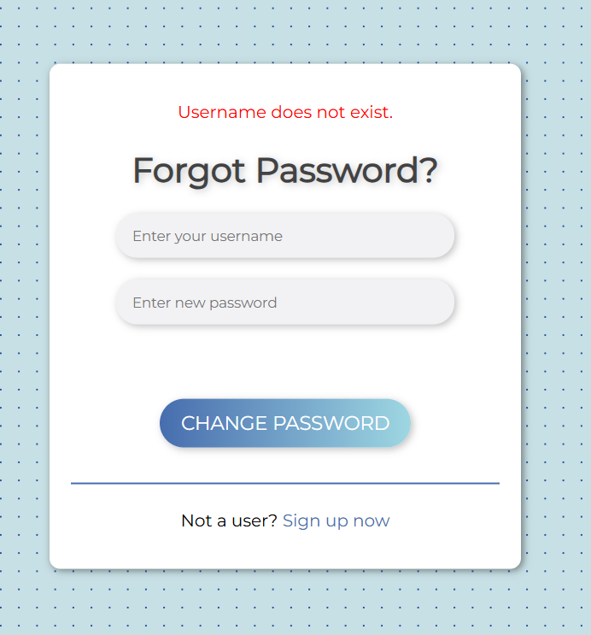

Sign Up
This screen this screen is opened when user clicks on the Sign-Up link, present on the Login and Forgot Password screens. The user can create an account.
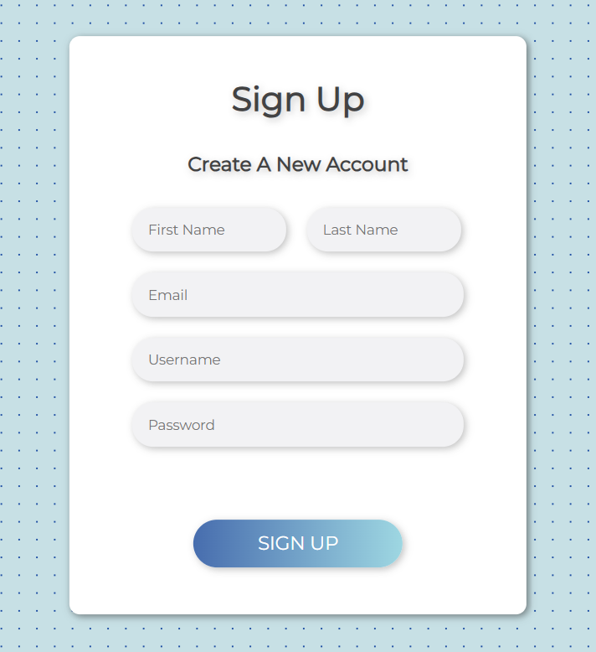

If the user enters an existing username, an error is shown. Otherwise, if the user has a unique username they are redirected to the login screen where they enter in their details and access their to-do list.
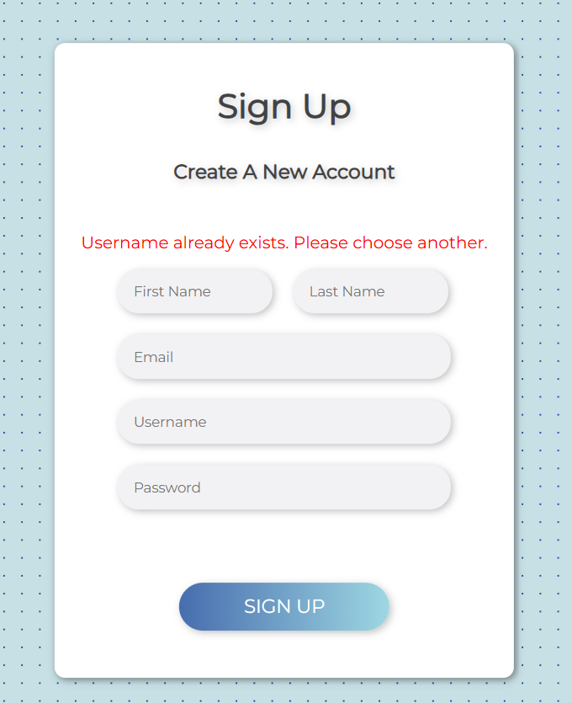
Home/To-Do List
The user can perform CRUD operations on their list and clicking on the logout button on the top right side, the user is logged out and redirected to the login screen.

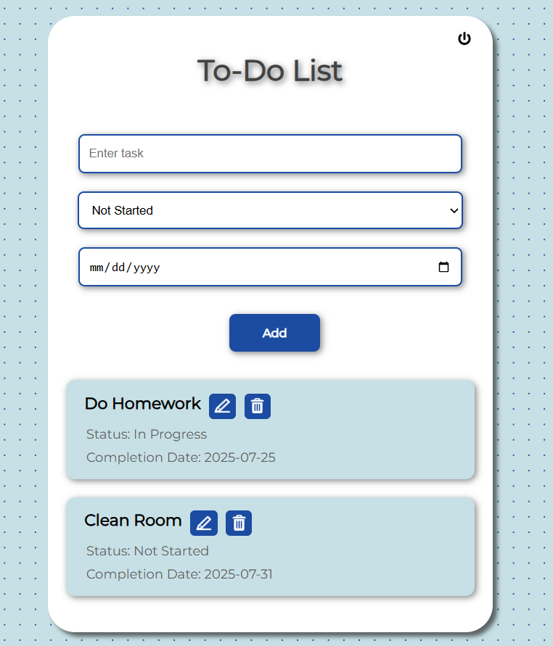
Edit
Edit Task window opens on clicking the edit icon next to a task. Here the user can change the task, its status or completion date.

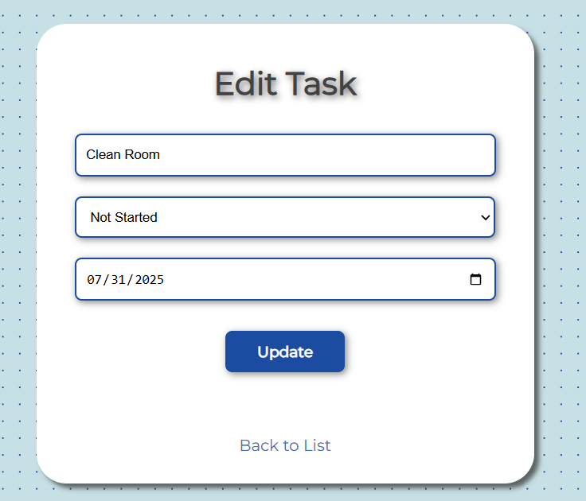

-
Benefits

User Benefits:
- Task Management Made Easy
- Progress Tracking
- Clean and User-Friendly Interface

Personal Benefits:
- Full-Stack Development Practice
- Understanding DBMS

Software Used
- Python
- Flask
- HTML/CSS
- MySQL
References
HTML & CSS
https://youtu.be/G3e-cpL7ofc?si=ho5uIE0xpEeNCAiJ
Javascript
https://youtu.be/jS4aFq5-91M?si=zh73clZEo0-wb3_U

Flask
https://youtu.be/Z1RJmh_OqeA?si=8zN15psU1IQvihSK

